AME532a Second Proposal Report

Jiaoran Wang

6205909903

Abstract

Introduction

This report uses ASW28 model for base model and

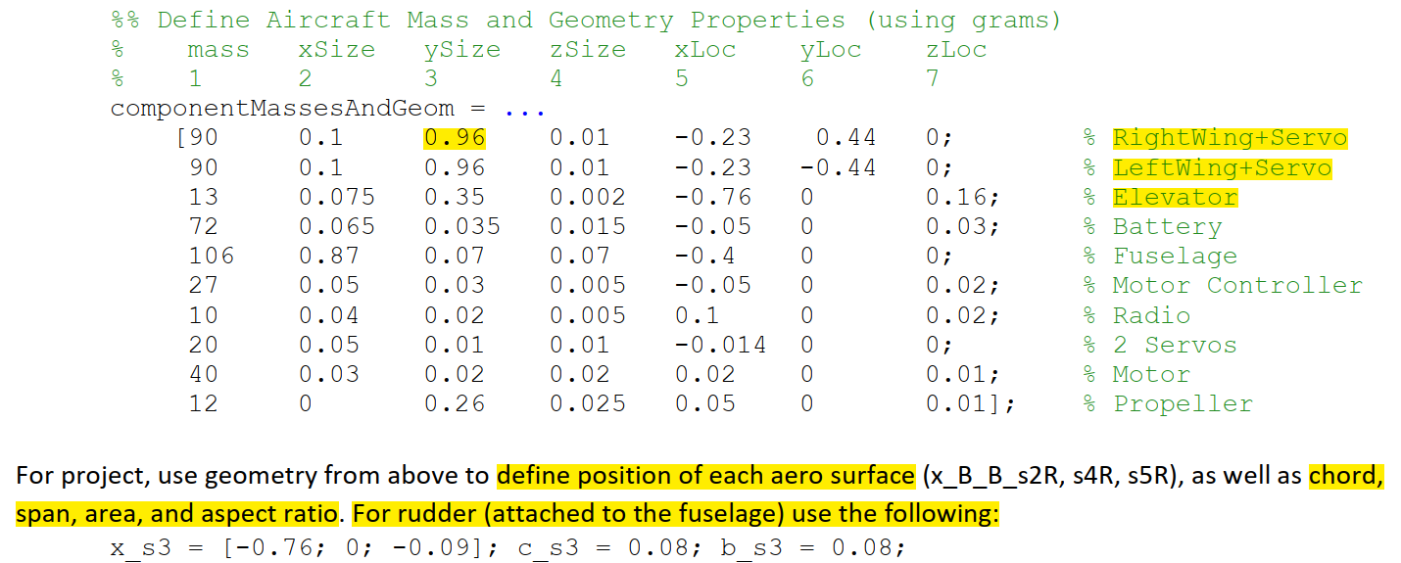

ASW28 Flight Control System

1. State Equations

2. Overall Control System

The dynamic control system contains five sub systems: Transform Kinetics & Dynamics, Rotational Kinetics & Dynamics and Aero Surface. Most of the imported parameters are calculated outside the Simulink blocks in order to reduce the number of systems calculating steps

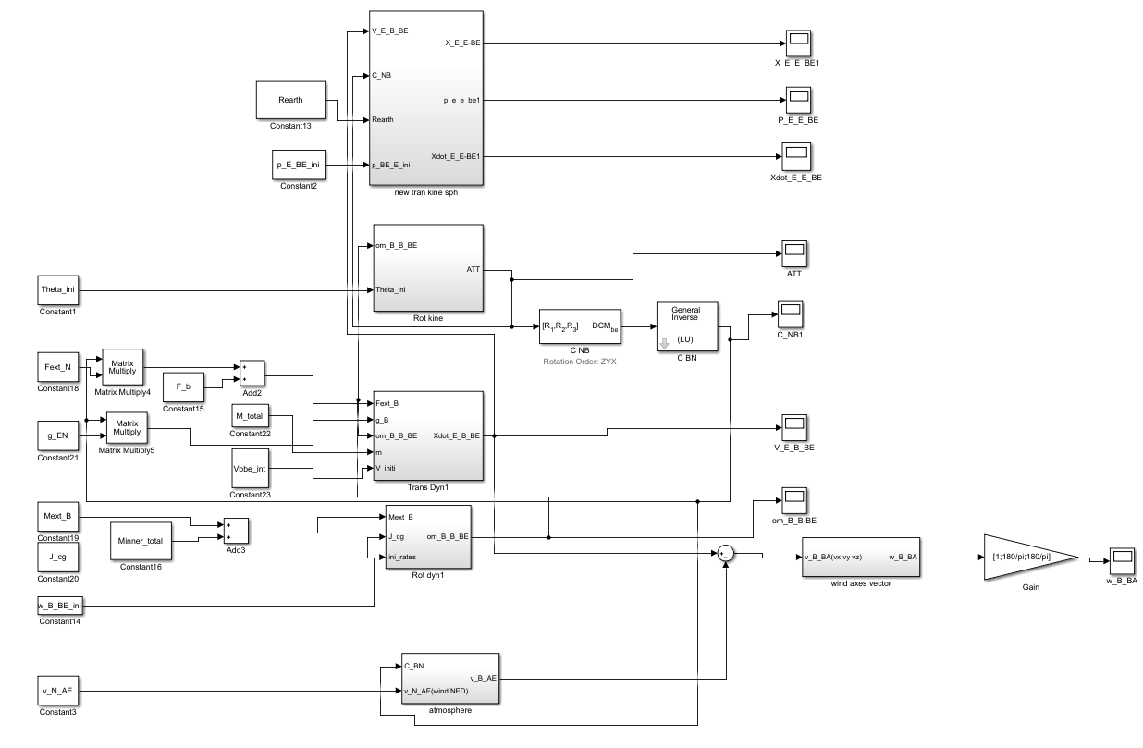

Figure 1-1. Control System

3. Controller Design

3.1 Autopilot Controller Concepts

The figure shows how autopilot control system works by using inner and outer feedback loop to control ailerons then reach desired roll positions. Following the same principle, we could

Figure 1-1. Autopilot Roll Angle Control Design

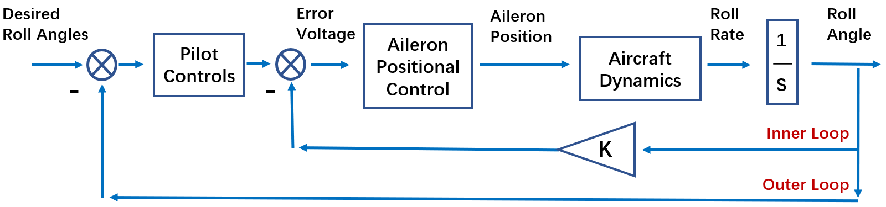

design different controllers for elevator to control pitch and rudder for yaw angles, in which case, the aero control system is added into the system. Besides, the parameters (such as V_inf) should change in real time.

1) Rolling Moment

Rolling moments are created by sideslip alone, by the control action of the ailerons and the rudder, and as damping moments resisting rolling and yawing motion.

The CL_s could be adding the aero surface infections according to the blocks

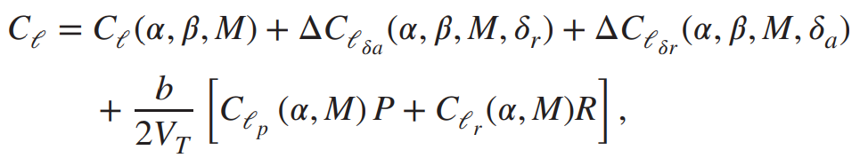

2) Pitching Moment

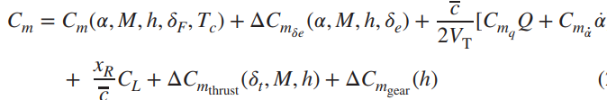

3) Yawing Moment

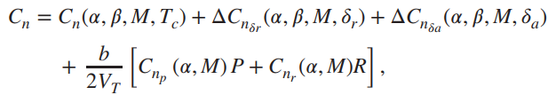

After applying the aero surface into the blocks, the inner force and moment will change in real time.

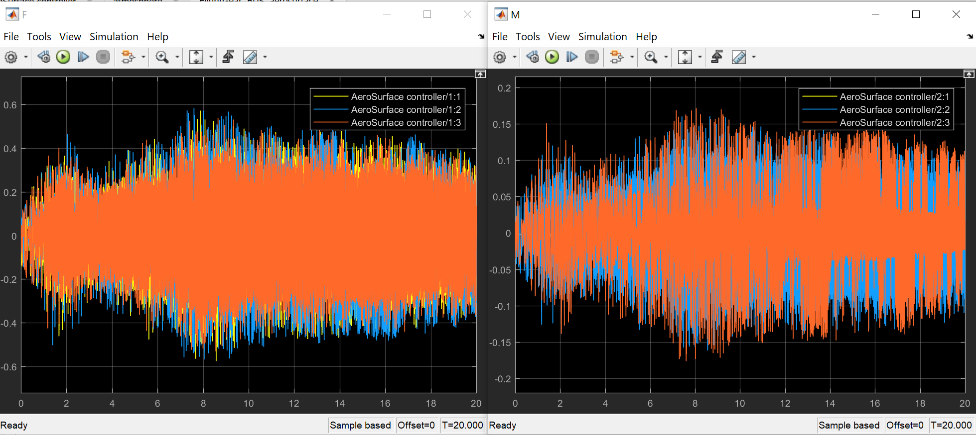

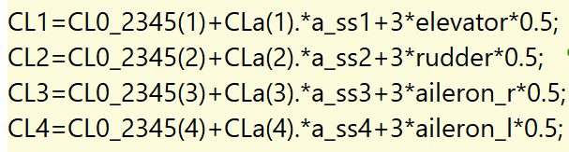

3.2 PID controller design

1) PID in Rotational Kinemics loop

Inside Rotational Dynamics, The PID controller is set up to eliminate the flight tremor during the cruising flight. Enlightened by autopilot block design in simulation, the PID controller is applied before Euler angle changed along the rotational rates in Body system respect to Earth reference frame. By using PID tuning system, the pitch and yaw offset curve could be trimmed

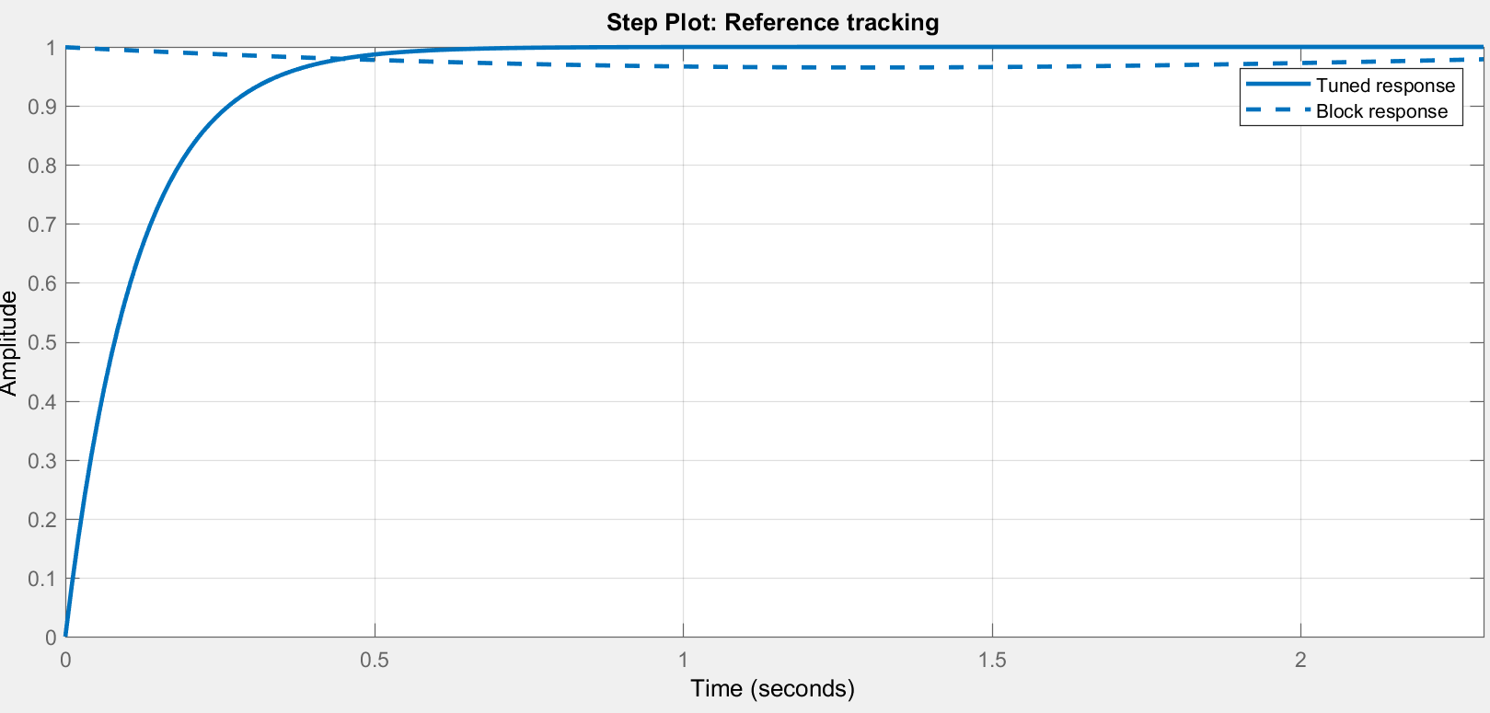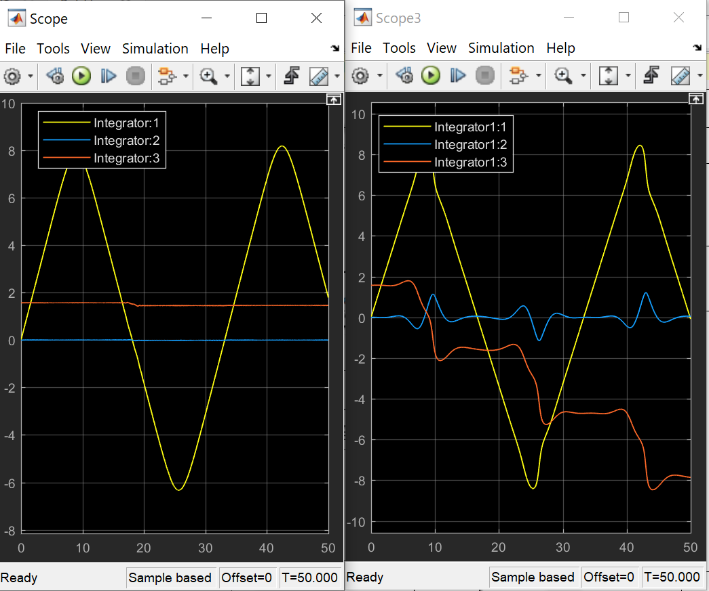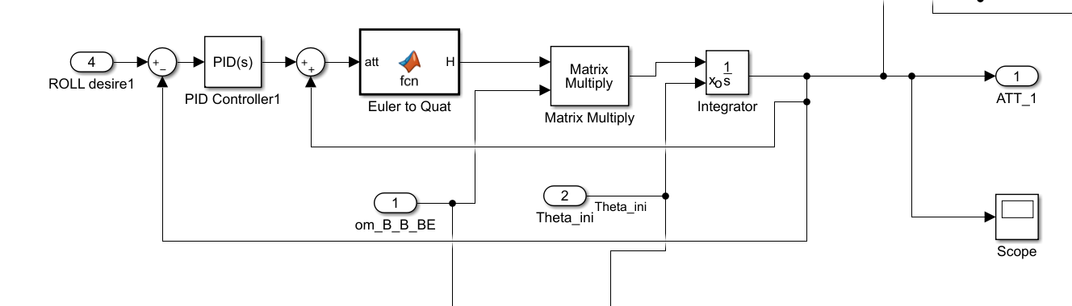

Figure 1-1. PID Controller Design for vibration elimination

2) PID for Single Angle Design

Yaw angle tuned

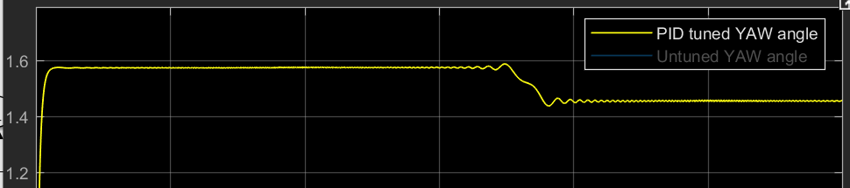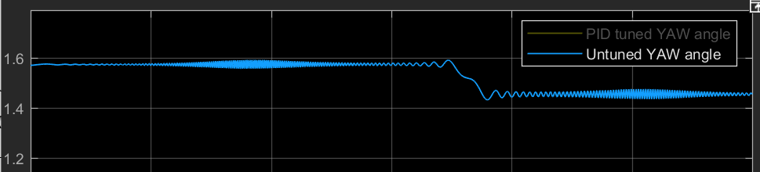

Figure 1-1. PID Controller Design for vibration elimination

3) Separate PID controller Design (Failed)

The three angles are coupled then I tried to use the separate:

Could not decouple them

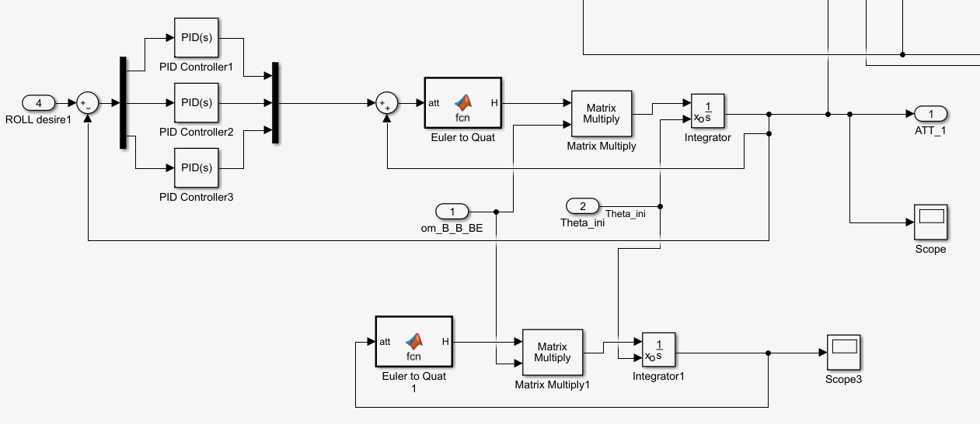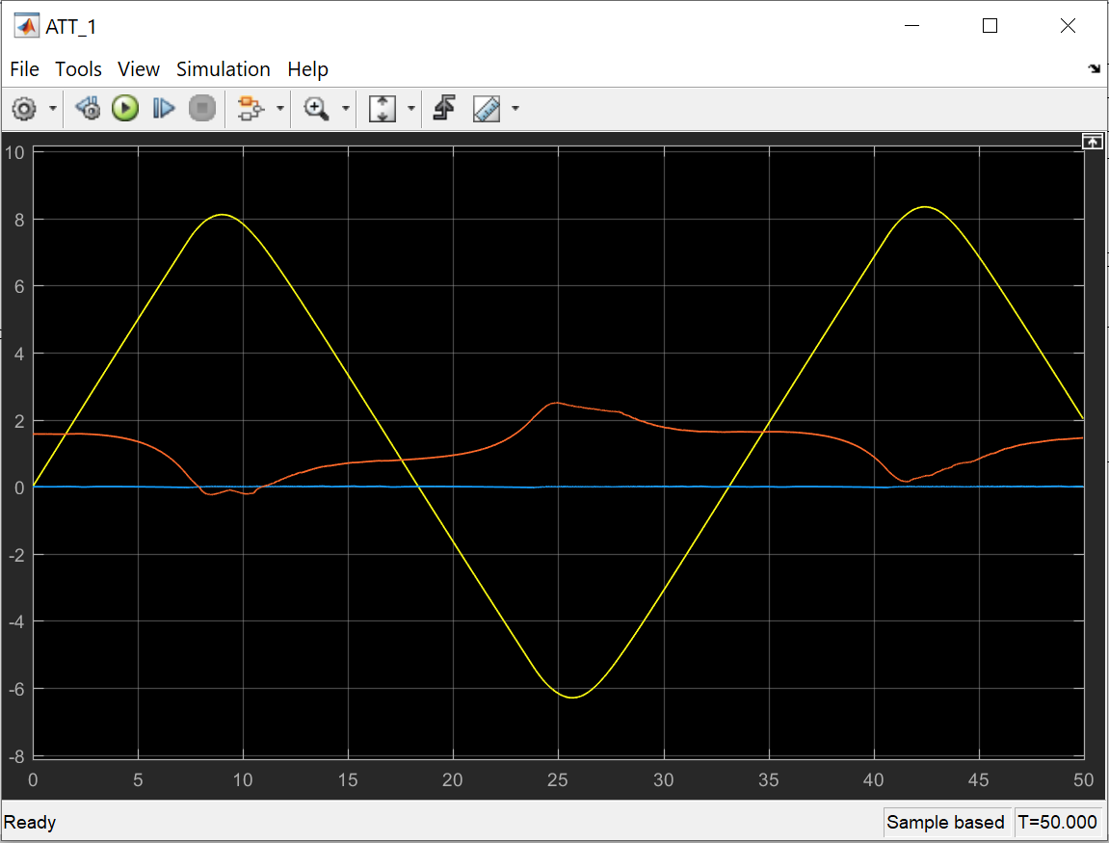

Model Trim and Linearization

1 Model Trim

By using Linear Analysis in Simulink, the twelve states could be trim to linearize the outputs. After discussing with teammates, we decide to trim these seven states: [Alt, Phi, Psi, V, P, Q, R]

1.1 Model Trim (without aero surface )

The results are showed below. The trimmed states are much linearized than untrimmed one. To be more particularly, the final simulation results have changed.

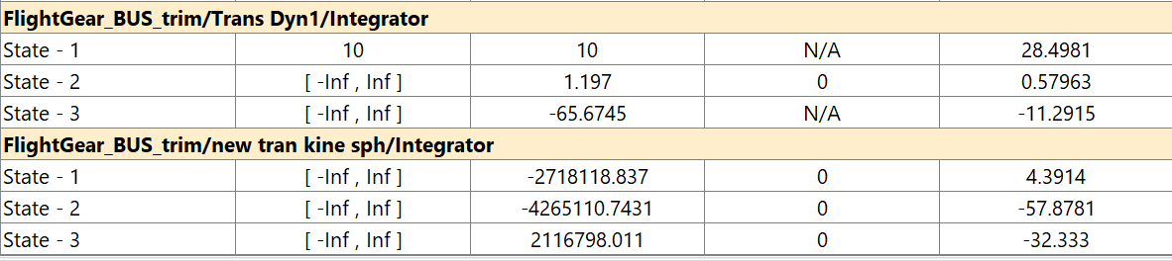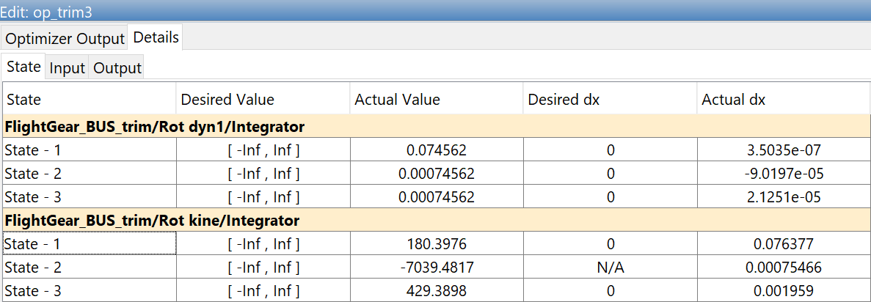

Figure 1-1. Linear Analysis Trim States

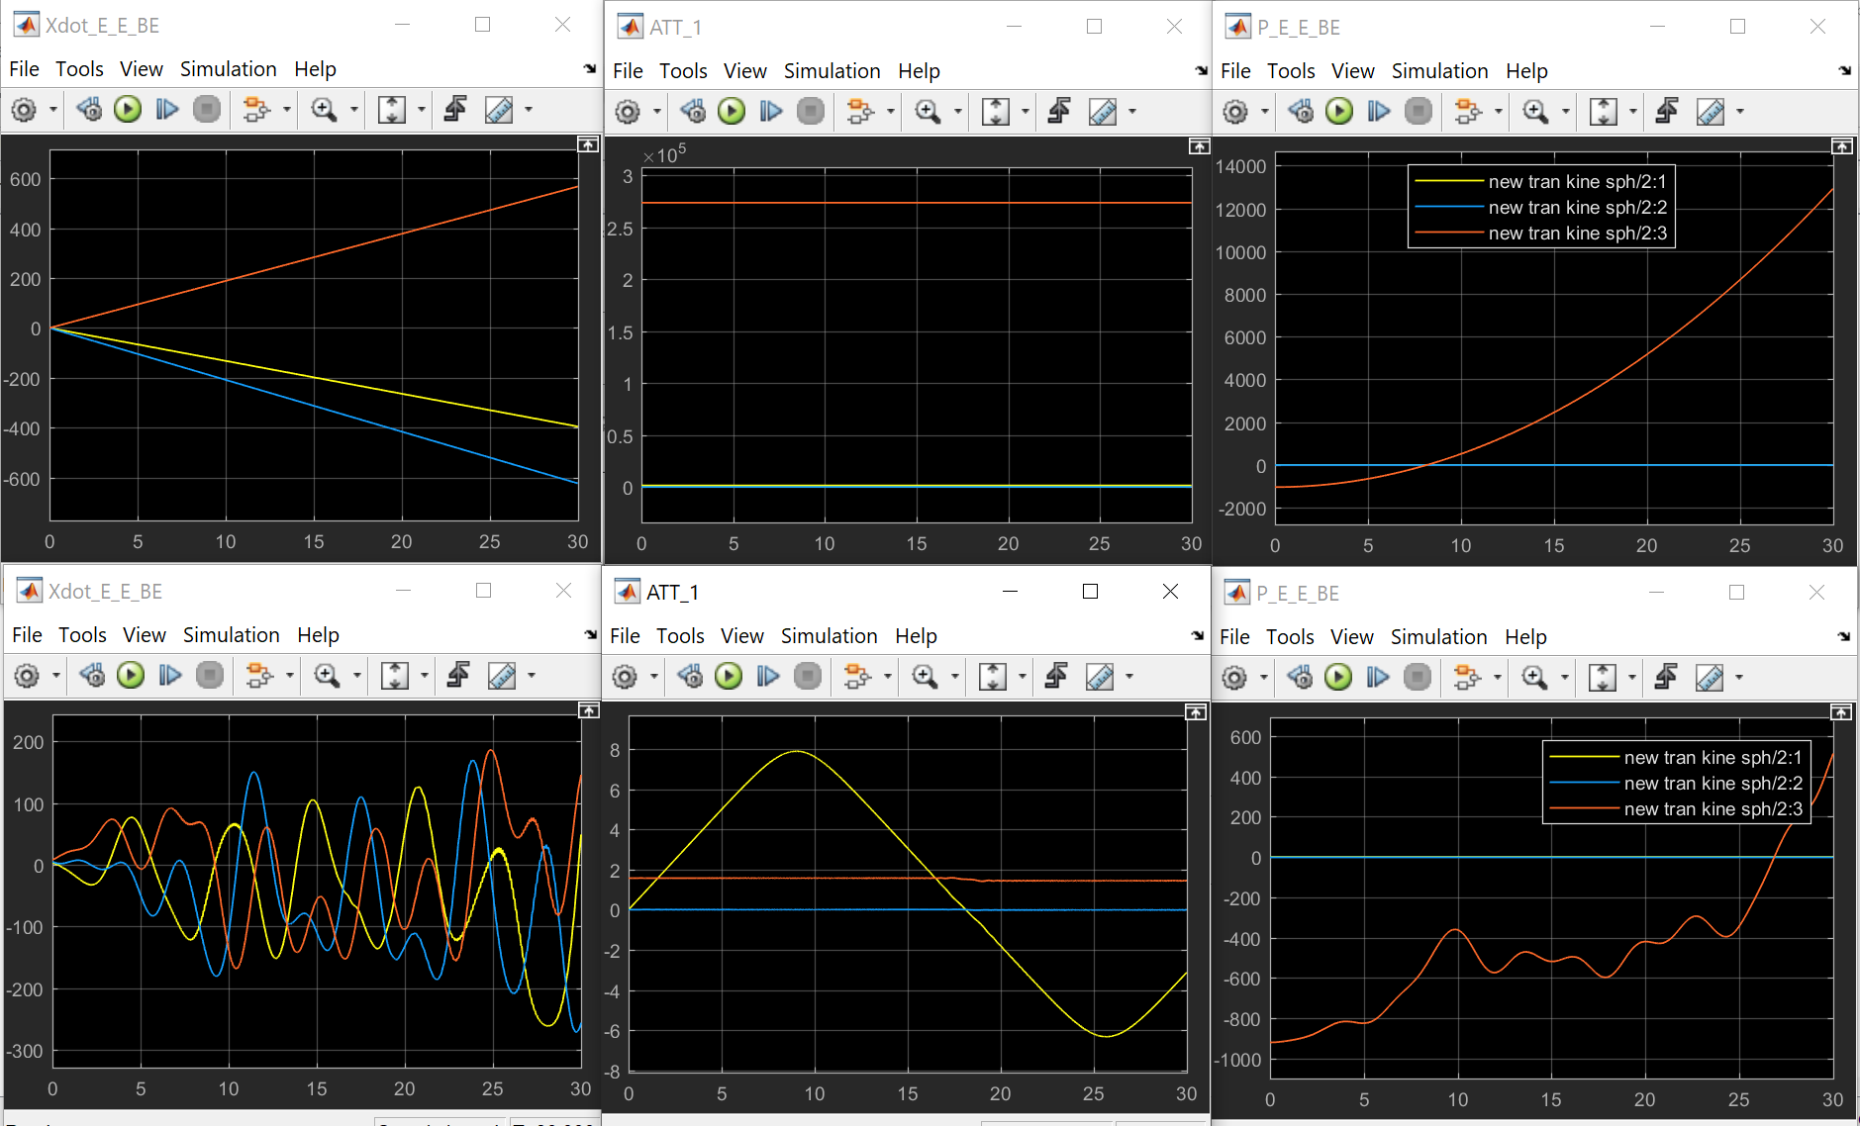

Figure 1-1. Trim Results (up: trimmed; down: untrimmed)

1.2 Model Trim (with aero surface)

After I apply the aero surfaces into the system:

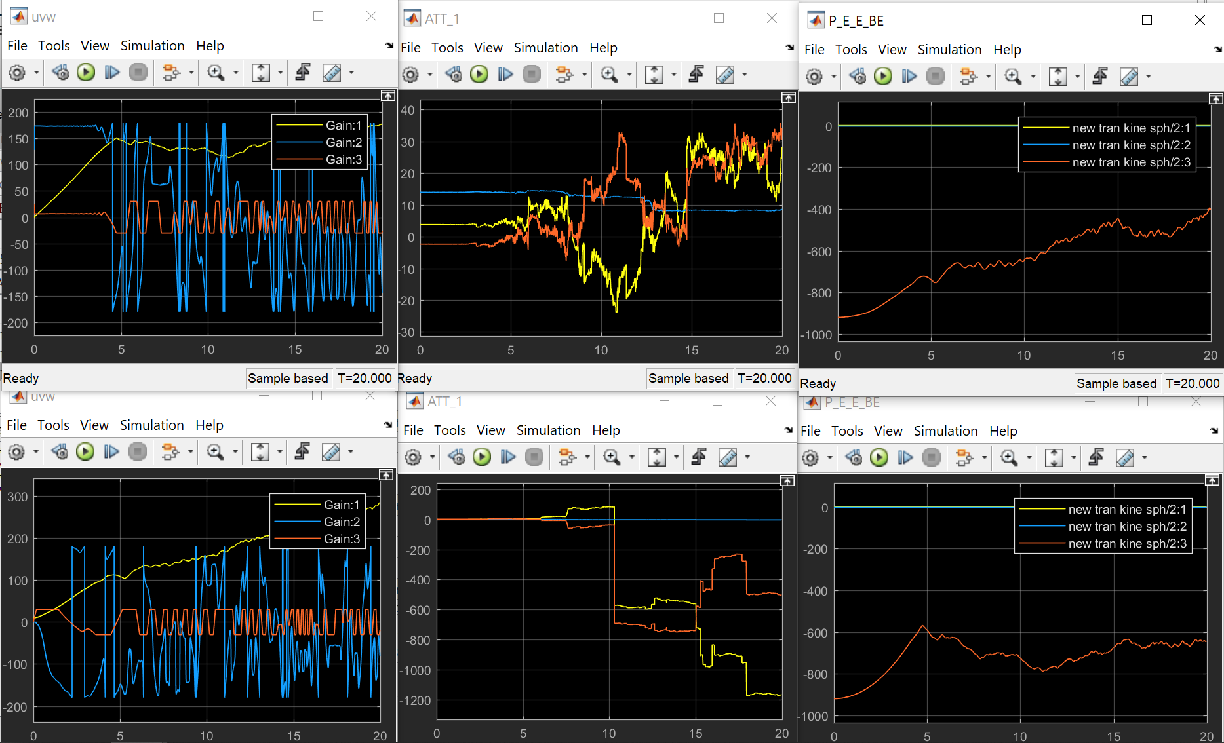

2 Model Linearization

The linmode() in Simulink should

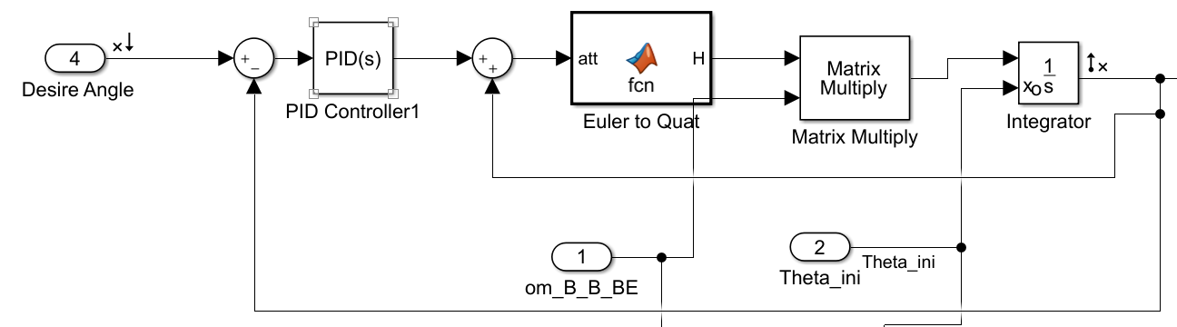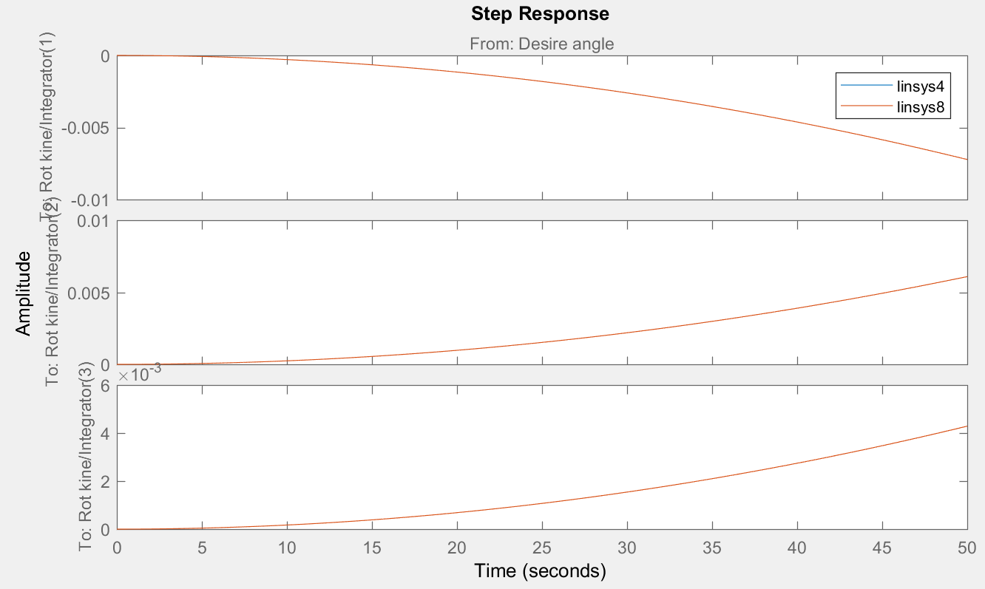

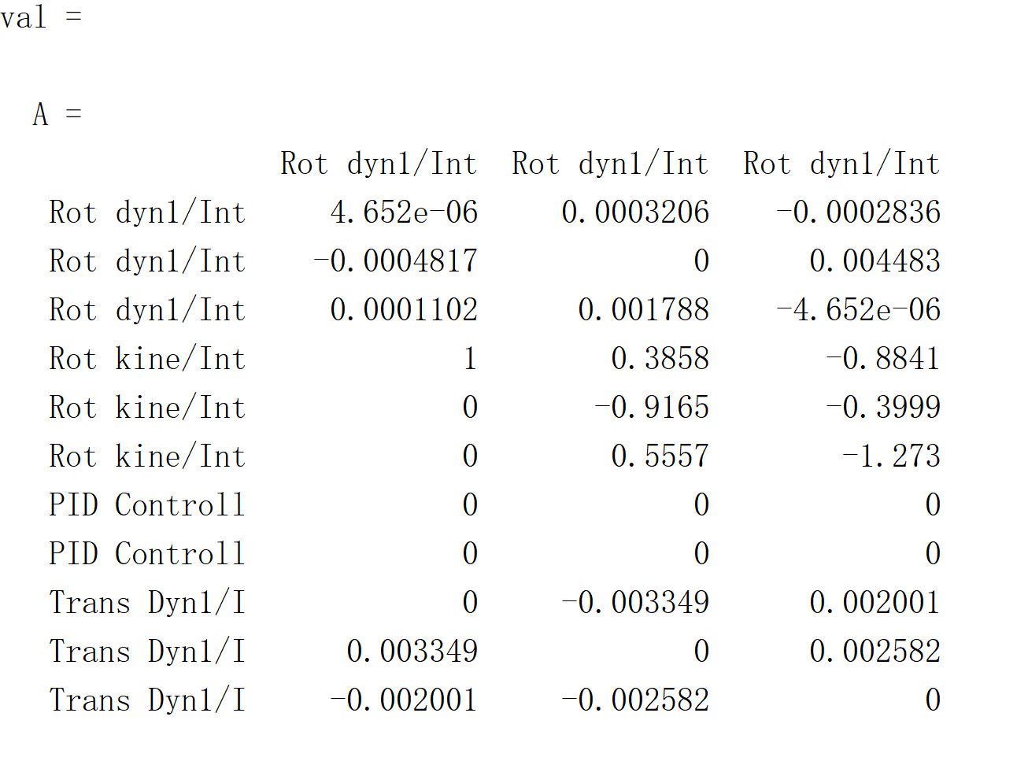

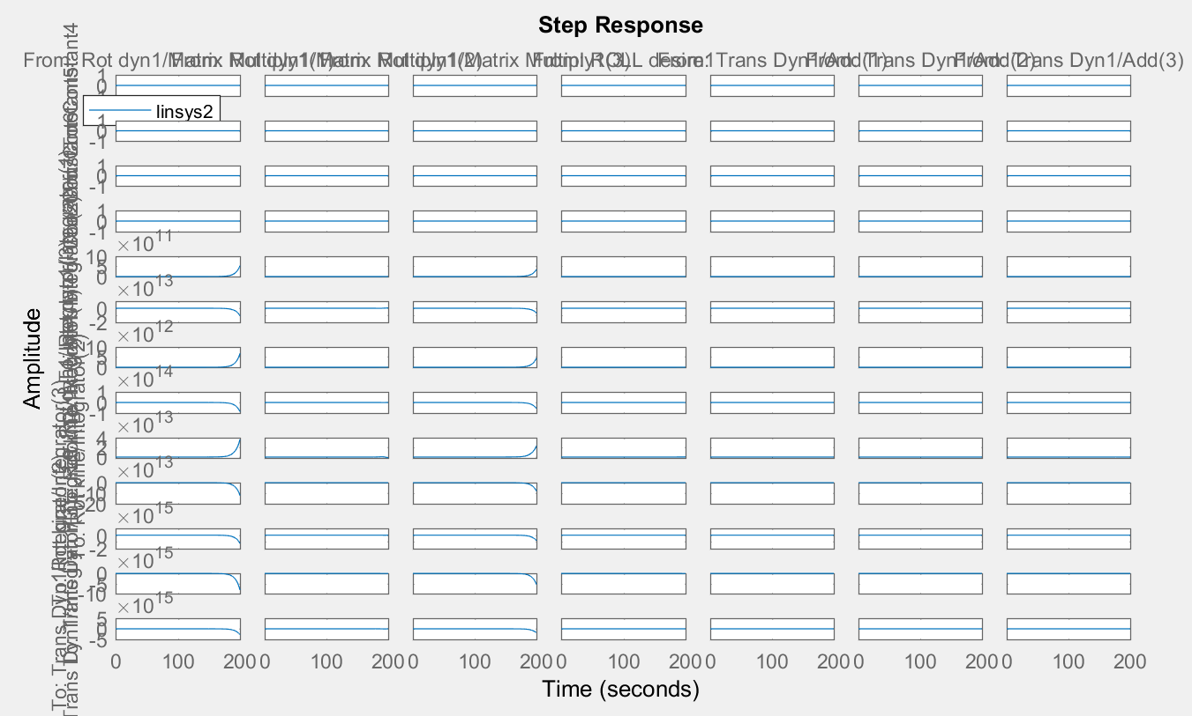

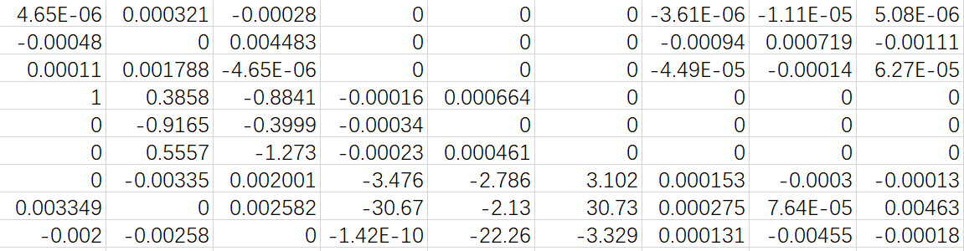

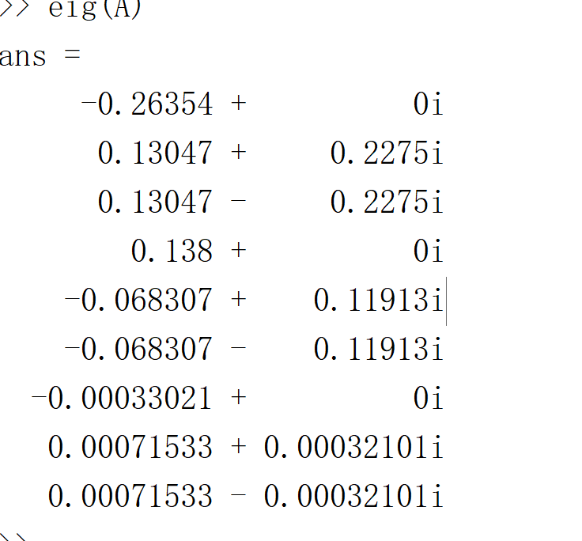

3. Perfect Linear States

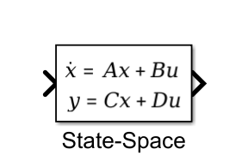

ASW28 Flight Dynamic Analysis

1. Introduction

2. XFLR5 Dynamic Analysis

2.1 Model Design

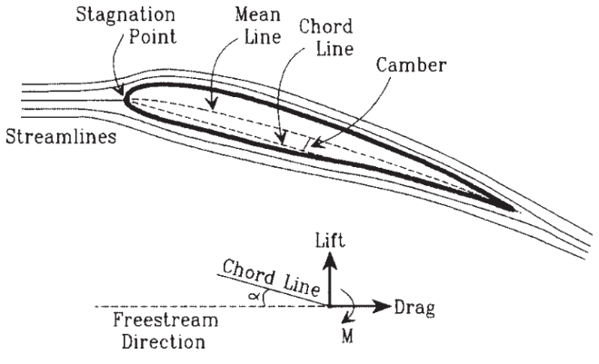

Figure 2.2-1 Definitions associated with an airfoil.

The model uses NACA 2412 data for main wing and elevator section and NACA 0009 for ruder section. By choosing proper sweepback angle and taper, the coefficients change along different alpha degree(-1.5 to 30 [deg])

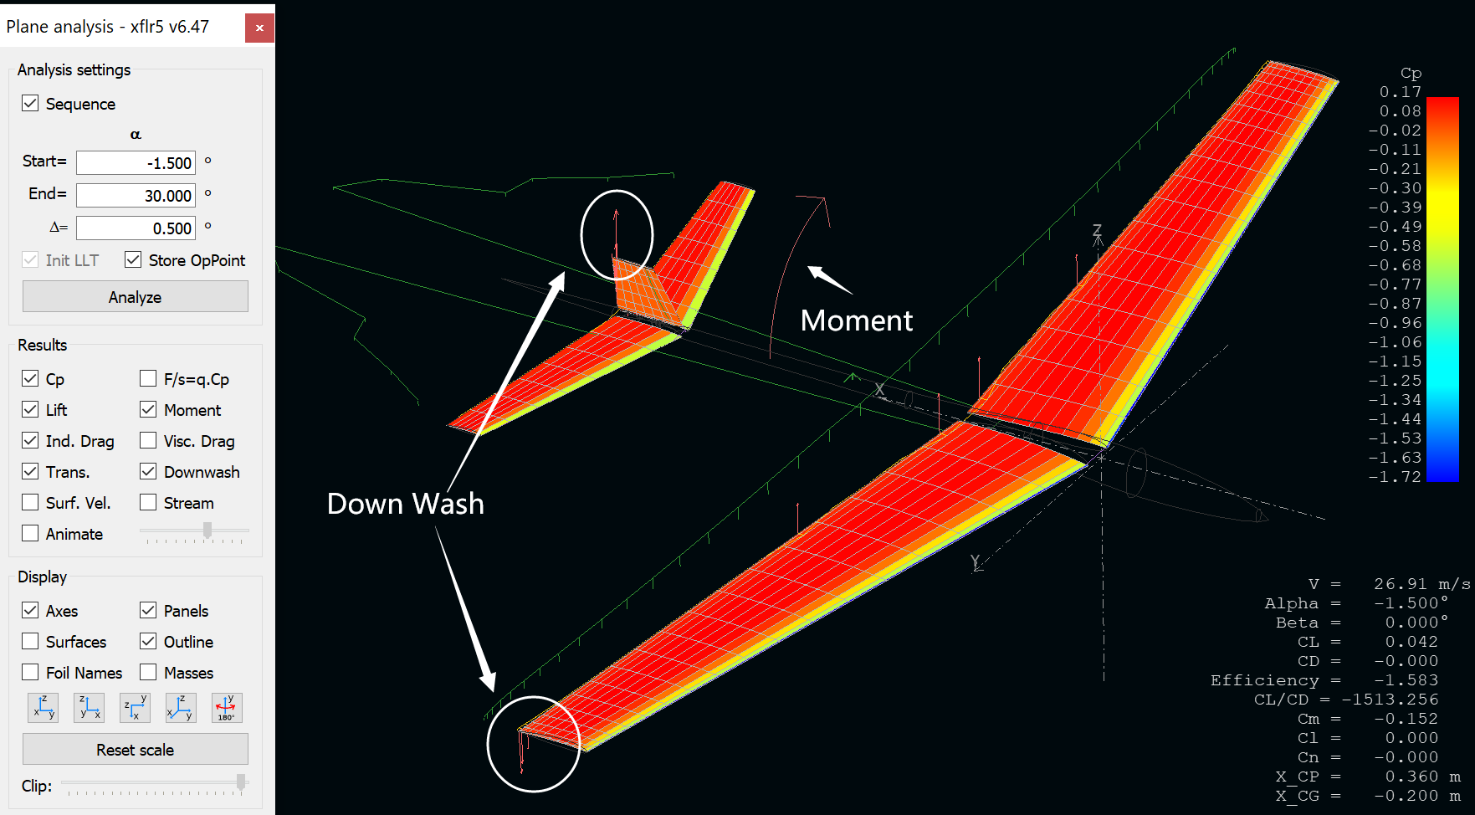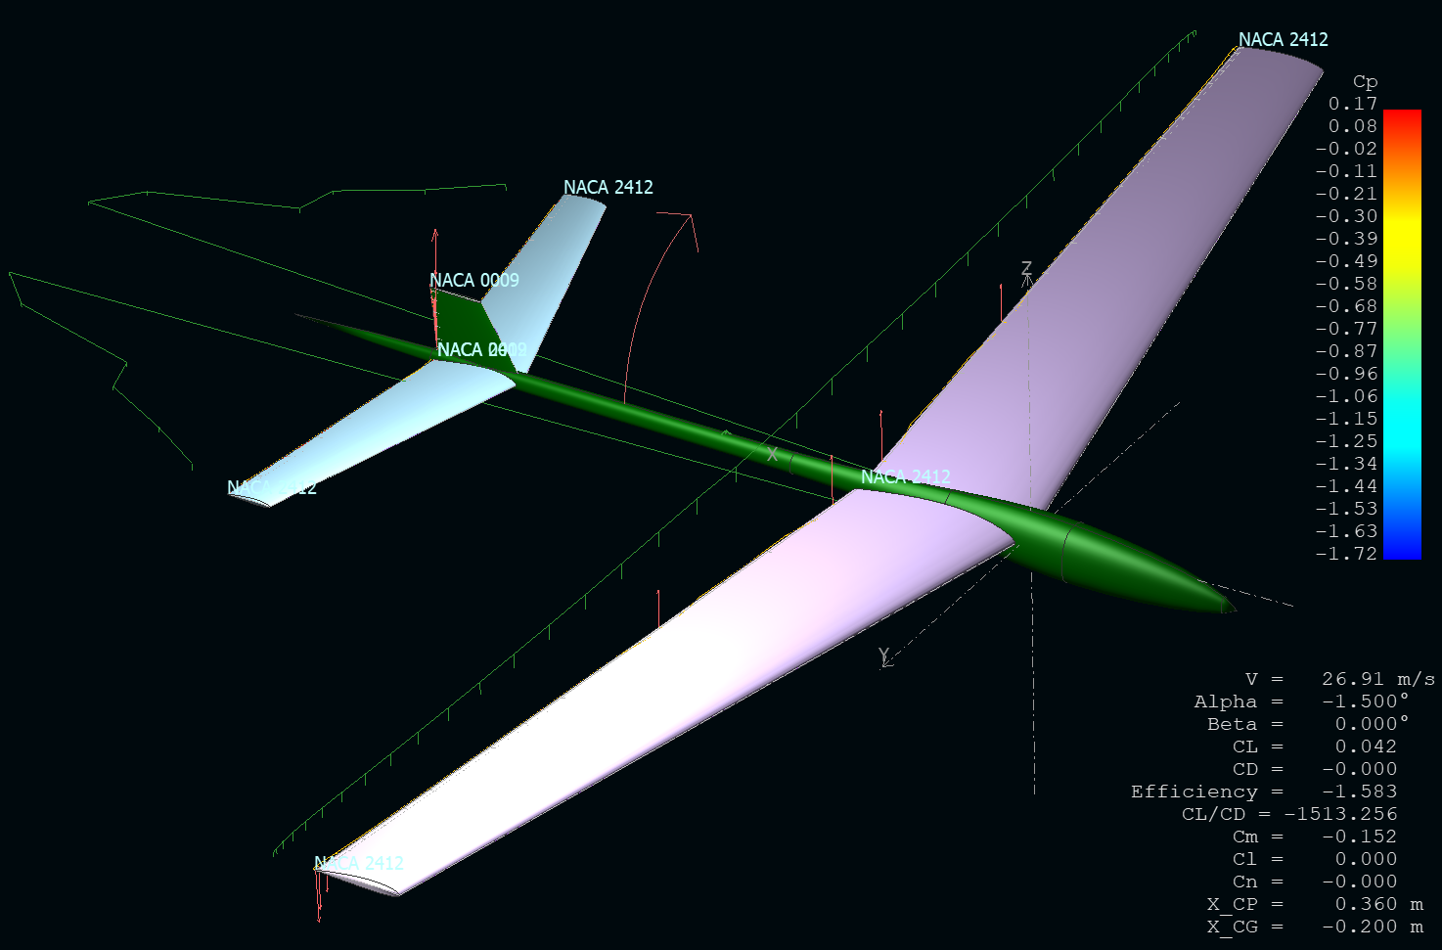

Figure 2.2-1 Definitions associated with an airfoil.

2.2 Dynamic Coefficient Calculation

The figure below shows without offset points.

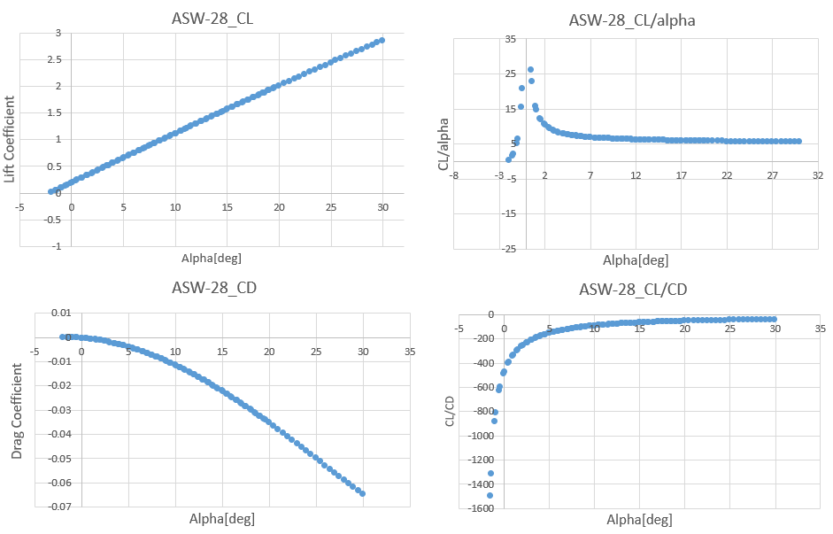

Figure 2.2-1 Definitions associated with an airfoil.

3. ANSYS Dynamic Analysis

3.1 Finite Element Analysis

By use ANSYS FLUENT module, the FEA analysis is applied to the whole

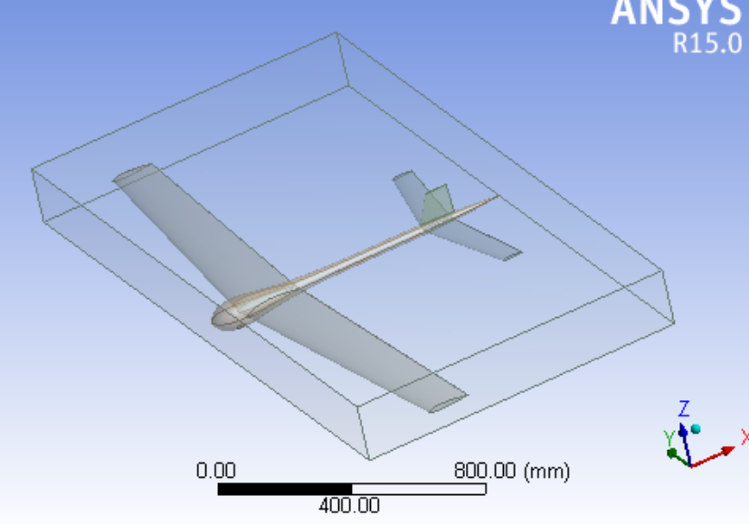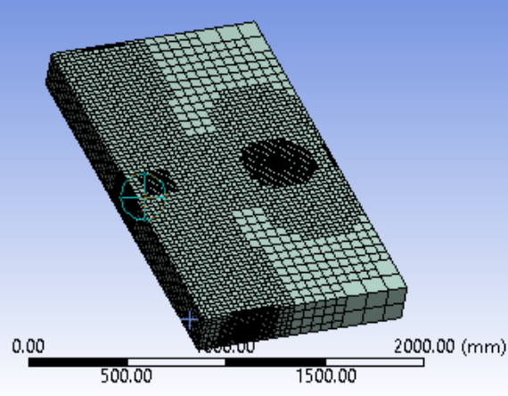

Figure 2.2-1 Definitions associated with an airfoil.

In order to control the variables in two methods, the model imported into ANSYS

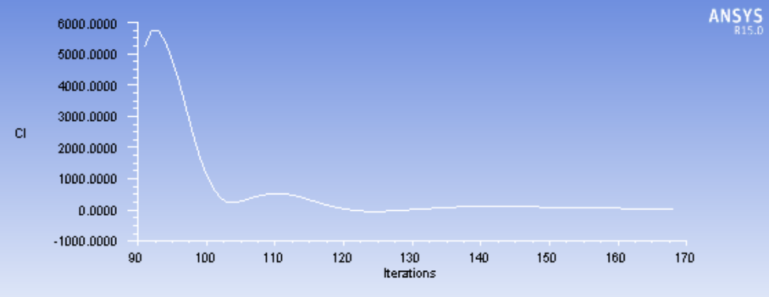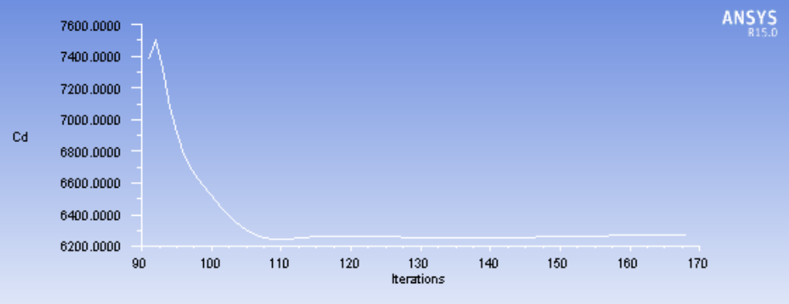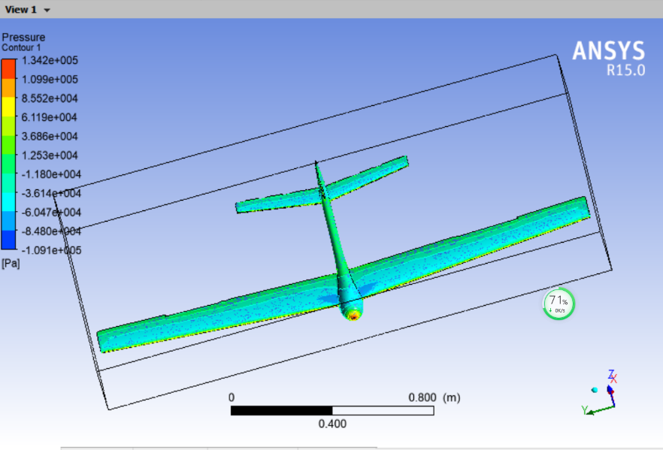

Figure 2.2-1 Definitions associated with an airfoil.

4. Results Comparison

4.1 Fuselage Analysis

4.2 Method Differences

4.2 Aerodynamic Parameter Distribution

1) Pressure Distribution

2) Streamline Distribution

5. Conclutions

Simulation

1. Connection to FlightGear

The block in aerospace basket is used to conneck MATLAB Simulink to FlightGear

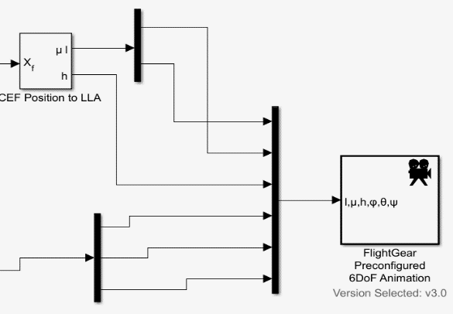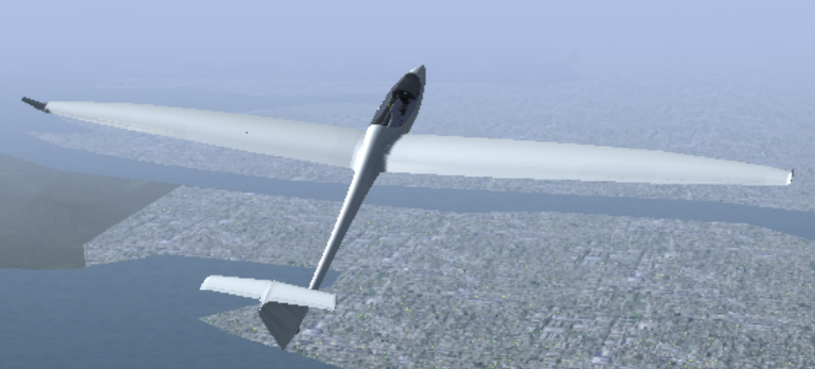

2. Lateral Motion Control

(See the book)

3. Long Motion Control

References